PUMP
CONTROL
HARNESS

USB
TO PC
FLOW
METER
HARNESS

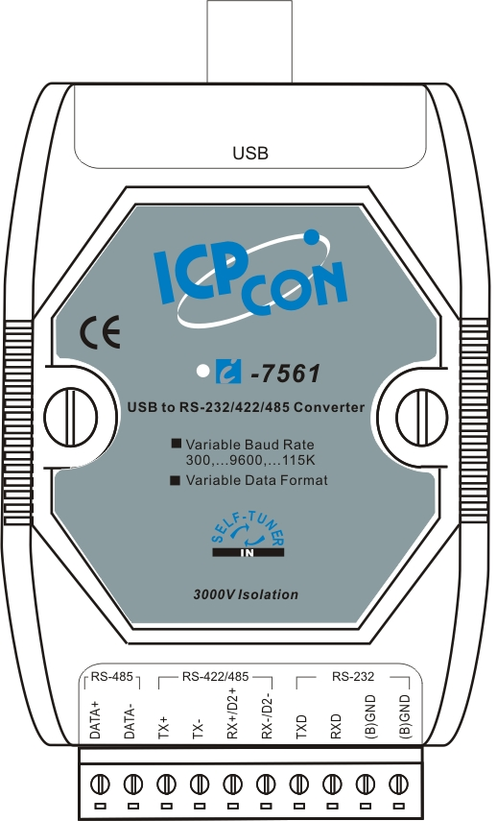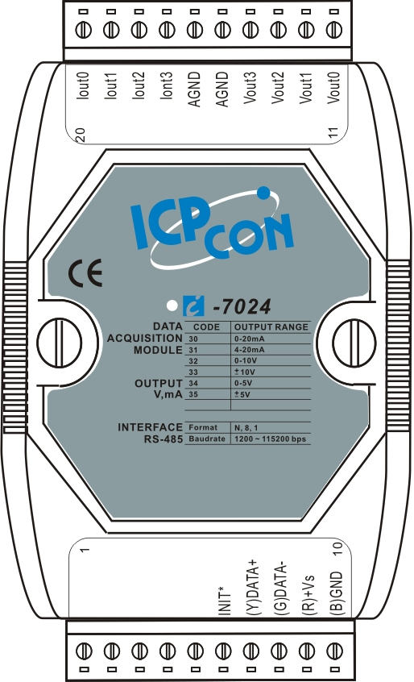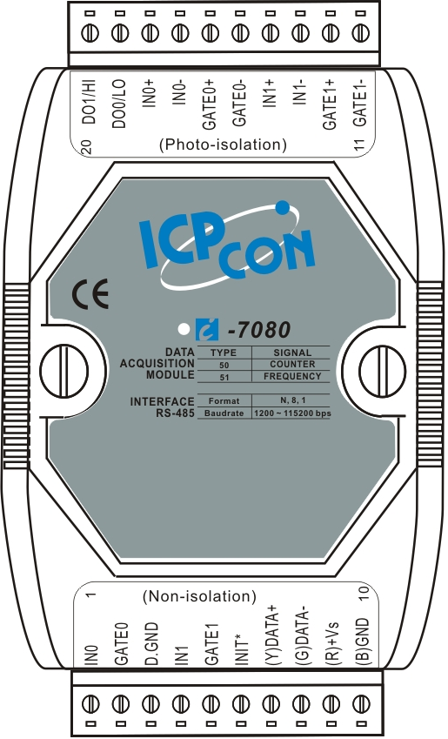
= White
+
-
24VDC
Supply

FUSE

Pump & Flow Meter Equipment Setup
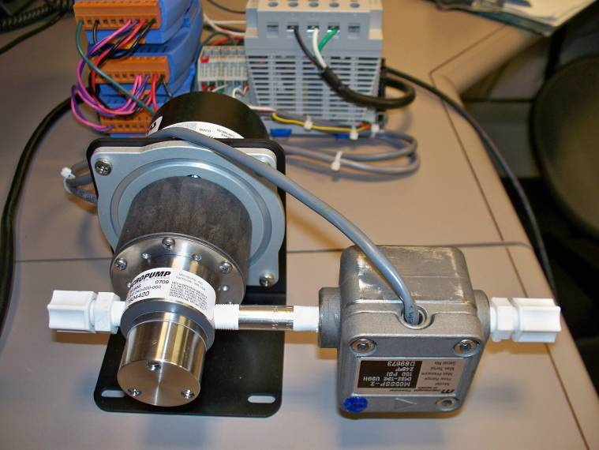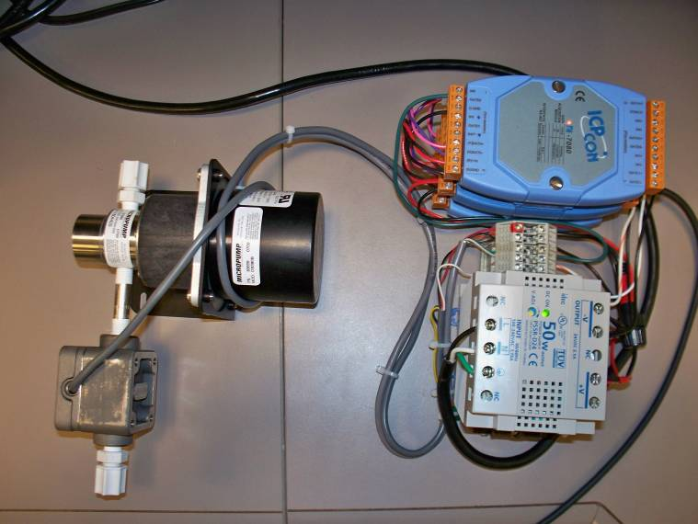
INPUT

